Bursting Disc Assembly Specification Sheet
To assist us with specifying a Bursting Disc assembly best suited for your application, please answer questions below:
Date : Company Name: Contact Name:
Telephone No. : Email : Enquiry Ref :
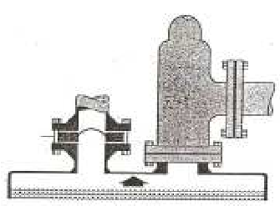  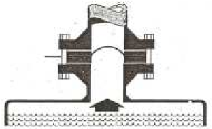  Typical Bursting Disc Installations  Secondary  Primary Secondary |  | 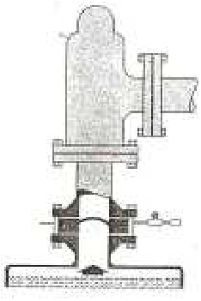  In series with SRV
Installation Tag Number / Identification Code
Is Bursting Disc installed as a : Primary, Secondary, or In Series with SRV
Design Code : PED EN-4126-2 / ASME VIII or other
Quantity of Bursting Discs required
Quantity of Bursting Disc Holders required
Disc size Required ( Nominal Bore Size )
Burst pressure & Temperature for the Disc
Max Operating Pressure & Temp. the Disc will see in service
Will disc be subjected to any vacuum conditions ( If yes, how much vacuum )
Will disc be subjected to any Back Pressure ( If yes, please state )
Will disc be subjected to cycling conditions
Acceptable materials for the Bursting Disc
M.A.W.P. of Vessel which is to be protected
Is fragmentation of the Bursting Disc allowed?
Acceptable materials for the Bursting Disc
Acceptable materials for the Bursting Disc Holder
Is a Gauge Tap required in Holder Outlet ( For Tell-Tale Assy. )
Medium in contact with the Bursting Disc on process side
Medium in contact with the Bursting Disc on vent side
Media state ( i.e. Liquid, GAS, or Vapour )
Flange Rating / facing required for the Disc / Holder assembly
Accessories
Burst Disc Indicator required ? – Yes / No
Excess Flow Gauge required ? – Yes / No
Pressure Gauge required ? – Yes / No
Pipe Guard Cover required ? Yes / No
If Disc Sizing & Flow Calculations are required, we will require the following information ;-
Process Media Name
Please state if it is a Gas / Vapour or Liquid Service
Molecular Weight / Specific Gravity
Viscosity
Ratio of specific heats
Compressibility Factor
Mass Flow Rate required through the Bursting Disc Assembly
Any other information which you think might help us in selecting the bursting disc assembly ;-

